1. Validation de la formule TKO Gross Commitment

|  |  |  |  |  |  |  |
| --- | --- | --- | --- | --- | --- | --- |
| ***Product*** | **Type Instrument** | **Cas de test** | **Résultat attendu** | **Résultat obtenu** | **Validé** | **Commentaire** |
| *Direct Investment Securities* | Debts Instruments | CFACE TCN 0,03 12/10/2015 | 0 | 0 | OK | Le TKO Gross Commitment doit être à zéro pour tous  les produits Direct Investment Securities |
| BONGRAIN TCN 0,16 27/04/2016 | 0 | 0 |
| Bonds | CFCM ARKEA  E20-05/12 E70-05/17 | 0 | 0 | OK |
| ABENGOA  8.875 02/18 | 0 | 0 |
| Shares | MCDONALD'S CORP | 0 | 0 | OK |
| AIR LIQUIDE SA | 0 | 0 |
| Indexes and Baskets | DJ EURO STOXX 50 | 0 | 0 | OK |
|  | | | | | | |
| *Options* | Listed Options | SX5E 18/12/15  C 4000 | 9 331 699.15 | 9 331 699.15 | OK | Delta = 0.0534610081  Underlying Last = 3491.03  Number of securities = 5000  Contract size = 10  Résultat = 0.0534610081*3491.03*5000*10 = 9 331 699.15 |
| Stock derivatives | CFR SW 12/18/15 P76 | 368 424.86 | 368 424.86 | OK | Delta = -0.4756938170  Underlying Last = 77.45  Number of securities = 100  Contract size = 100  Résultat = -0.4756938170*77.45*100*100 = 368 424.86 |
|  | | | | | | |
| *Forex* | Forex | CAD versus CHF | 0 | 0 | OK | Le TKO Gross Commitment doit être à zéro pour tout le produit Forex |
| EUR versus CHF | 0 | 0 |
| JPY versus USD | 0 | 0 |
|  | | | | | | |
| *FX Options* | Exchange Rate Options | ECH5C 1.30 COMB curn te | 6 968 273.24 | 6 968 273.24 | OK | Nominal = 125 000 000  Delta = 0.0557461859  Résultat = 125 000 000*0.0557461859= 6 968 273.2375 |
|  | | | | | | |
| *FX Forwards* | Forward Forex | EUR versus GBP  2016/07/22 | 1 790.47£ | 1 790.47£ | OK | Devise du fond = EUR  Devise de la position = GBP  Une seule transaction dans la position -🡪  (A = A1 ; B= B1 )  A1 = 0 (Montant dans la devise du fond)  B1 = 1 790.47£  Résultat = Abs(0) + Abs(1 790.47)= 1 790.47£ |
| USD versus EUR  2016/08/10 | 2 160.41€ | 2 160.41€ | Devise du fond = EUR  Devise de la position = EUR  Une seule transaction dans la position -🡪  (A = A1 ; B= B1)  A1 = 2400.0$ = 2400$/1.1109(Last €/$) = 2160.41€  B1 = 0 (Montant dans la devise du fond)  Résultat = Abs(2160.41€) + Abs(0) = 2160.41€ |
| HKD versus JPY 2016/09/09 | 198 388.34 JPY | 198 388.63 JPY | Devise du fond = EUR  Devise de la position = JPY  Deux transactions dans la position -🡪  (A = A1 + A2 ; B= B1 + B2)  A1 = 3600 HKD; A2 = 2600 HKD;  A = 6200HKD=6200HKD*16.0279473(Forex HKD vs JPY)  = 99372.98 JPY  B1 = 57492.79 JPY; B2 = 41522.57JPY;  B= 99015.36 JPY  Résultat = Abs(99015.36 JPY) + Abs(99372.98 JPY) = 198388.34 JPY |
| CHF versus HKD  2016/05/22 | 14331.3 HKD | 14331.3 HKD | Devise du fond = EUR  Devise de la position = HKD  Deux transactions dans la position -🡪  (A = A1 + A2 ; B= B1 + B2)  A1 = 1200 CHF; A2 = -300 CHF; A = 900 CHF = 7 151.69 HKD  B1 = 9572.81 HKD; B2 = 2393.20 HKD; B= 7179.61 HKD  Résultat = Abs(7 151.69 HKD) + Abs(7179.61 HKD) = 14331.3 HKD |
| CHF versus USD  2016/06/06 | 410.59 | 410.59 | Devise du fond = EUR  Devise de la position = USD  Deux transactions dans la position -🡪  (A = A1 + A2 ; B= B1 + B2)  A1 = -700 CHF; A2 = 500 CHF; A = -200 CHF = -204.91 USD  B1 = -719.86 USD ; B2 = 514.18 USD; B= -205.68USD  Résultat = Abs(-204.91 USD) + Abs(-205.68USD) = 410.59$ |
|  | | | | | | |
| *Index Futures* | Index Futures | VGU4 Index test | 87 275 750 | 8 727 5750 | OK | Number of Securities = 2500  Contract size = 10  Underlying Last = 3 491.03  Résultat = 2500*10*3 491.03= 87 275 750 |
| GXZ6 EUX Index test | 1 515 949 320 | 1 515 949 320 | Number of Securities = 5520  Contract size = 25  Underlying Last = 10 985.14  Résultat = 5520*25*10 985.14= 1 515 949 320 |
| *Bond pool Futures* | Interest Rate Futures | DUM5 Comdty test | 1 020 380 | 1 020 380 | OK | Number of contracts = 10  notional contract size = 1000  market price of the cheapest-to-deliver reference bond = 102.0380  Résultat = 10* 1000 * 102.0380 = 1 020 380 |
|  | | | | | | |
| *CDS*  *(Single Name)* | Credit default Swap & Underlying = Bonds | **Bond (nb >0)**  CDS XS1204272709 Corp | 5774.76 | 5774.76 | OK | Nominal = 6000  Underlying Last (%) = 96.246/100 = 0.96246  Résultat = 6000 * 0.96246 = 5774.76 |
| **Bond (nb <0)**  CDS XS0954676366 Corp | 3403.9152 | 3403.9152 | OK | Nominal = -2800  Underlying Last (%) = 121.5684/100 = 1.215684  Résultat = MAX (abs(-2800); abs(-2800*1.215684))  = 3403.9152 |
| Credit default Swap & Underlying = Issuer | **Issuer** | 150 | 150 | Ok | Nominal = 150  Résultat = 150 |
|  | | | | | | |
| *CDS Index* | Credit default Swap & Underlying = Index | ITRX XOVER CDSI S23 5Y | 713 | 713 | OK | Nominal = -713  Résultat = Abs (-713) = 713 |
|  | | | | | | |
| *Convertible Bonds* | Convertibles and Indexed | ABENGOA 4 1/2 02/03/17 CB | 25 600 095.76 | 25 600 107.51  (petite difference due au nb de decimal du conversion ration) | OK | Conversion Ratio = 9345.79  Number of Securities = 3500  Underlying Last = 3.216  Delta = 0.24335568  Résultat = 9345.79*3500*3.216*0.24335568 =  25 600 095.7630895232 |
|  | | | | | | |
| *Swaps* | Interest Rate Swaps | IR SWAP EUR 06/13 4,905 | 512 000 | 512 000 | OK | Nominal = 512000  Résultat = Abs (512000) = 512000 |
| IR SWAP BNPP (1,21%) 31/05/2020 | 200 | 200 | Nominal = -200  Résultat = Abs (-200) = 200 |
|  | | | | | | |
| *Basic TRS* | TRS | IBOXX TRS 167,72 12/14 | 465.23 | 465.23 | OK | Nominal = 460  underlying Last = 169.6287  Underlying Initial Price= 167.72  Résultat = 460*169.6287/167.72 = 465.23 |
|  | | | | | | |
| *FX Futures* | Exchange rate future | Euro USD FX FUT Jun 16 | 6 250 000 | 6 250 000 | OK | Number of securities = 50  Contract size = 125 000  Résultat = 50 * 125 000 = 6 250 000 |
|  | | | | | | |
| *Option on future on bond pool* | Interest Rate  Derivative  Uderlying = IR Future | TYM5C 129.0 Comdty | 64 156 250 | 64 156 250 | OK | Volatility= 0 (dans ce cas il faut mettre delta à 1 dans la formule)  Underlying Last = 128.3125  Number of securities = 500  Contract size = 1000  Résultat = 1*128.3125*500*1000= 64 156 250 |
| TYM5C 129.0 Comdty test | 78 636 740.02 | 78 636 740.02 | OK | Delta = 0.4762976379  Underlying Last = 127  Number of securities = 1300  Contract size = 1000  Résultat = 0.4763*127*1300*1000 = 78 636 740.02 |
|  | | | | | | |
| *Repos* | Loan On Stock  NBR < 0 | Repo TUI GR FRN PerpTC+ | 500 625 | 500 625 | OK | Nb Securities = -500  Contract size = 10  Underlying Last = 100.125  Résultat = 500*10*100.125 = 500 625 |
|  | | | | | | |
| *Reverse Repos* | Loan On Stock  NBR > 0 | Repo TUI GR FRN PerpTC+ | 0 | 0 | OK | Résultat = 0 |
|  | | | | | | |

1. Validation TKO Gross Commitment Curr. Portfolio et TKO Gross Commitment in % of NAV

**

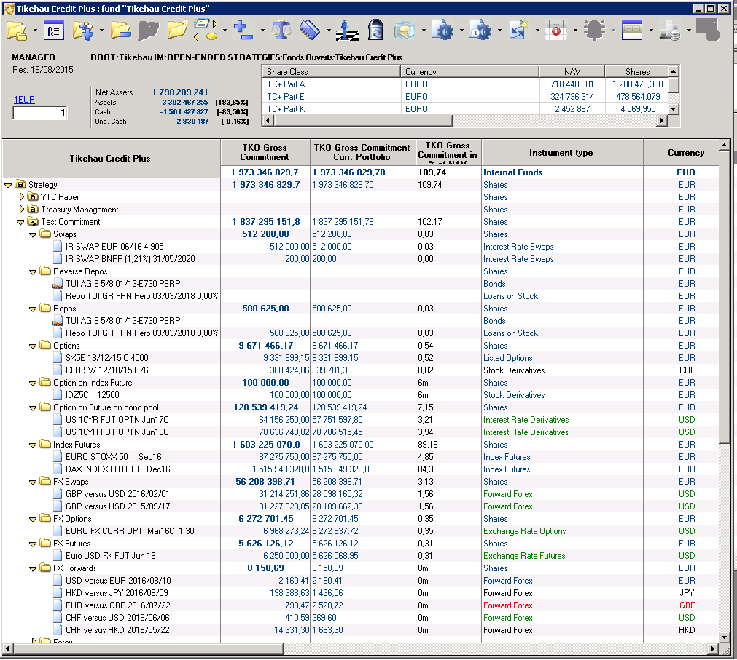

Annexe

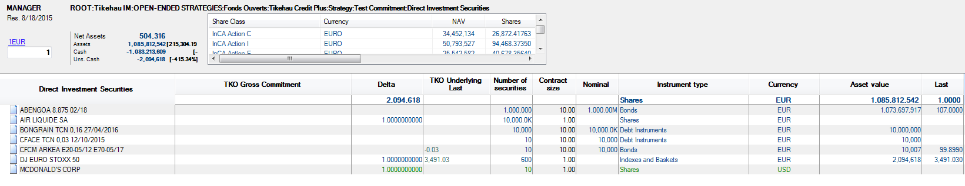

*Direct Investment Securities*

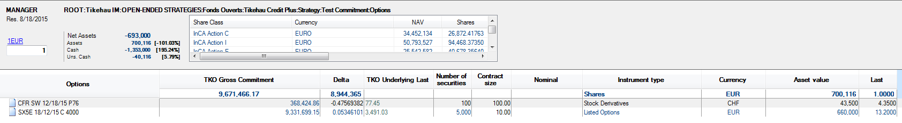

*Options*

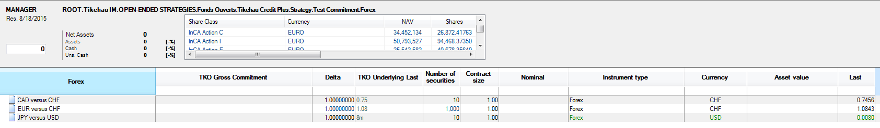

*Forex*

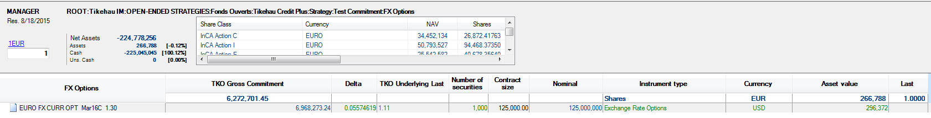

*FX Options*

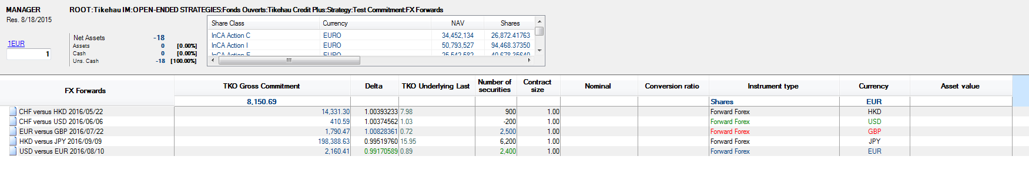

*FX Forwards*

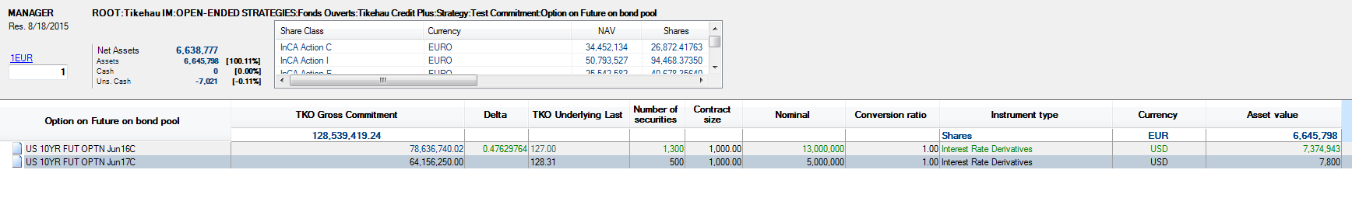

*Option on future on bond pool*

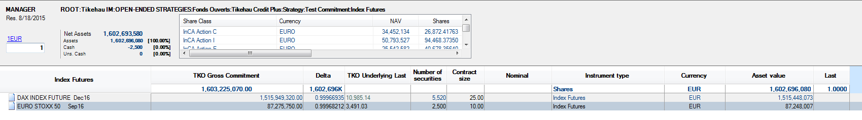

*Index Futures*

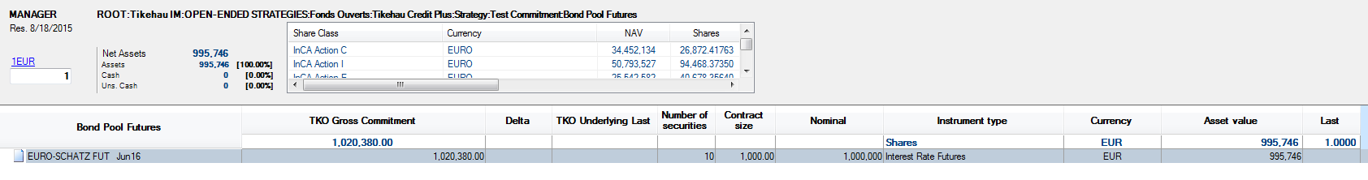

*Bond Pool Futures*

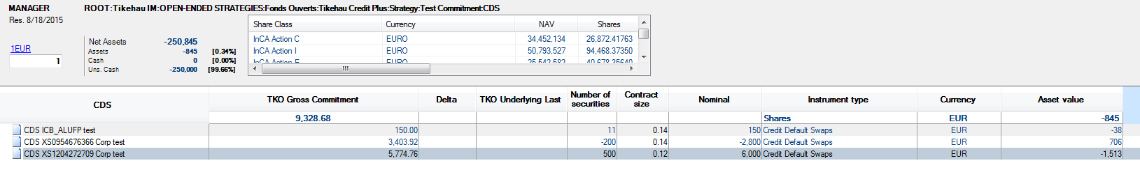

*CDS (single Name)*

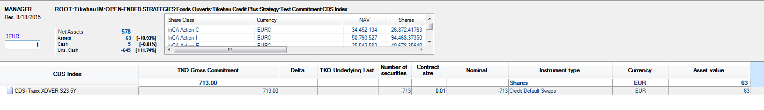

*CDS Index*

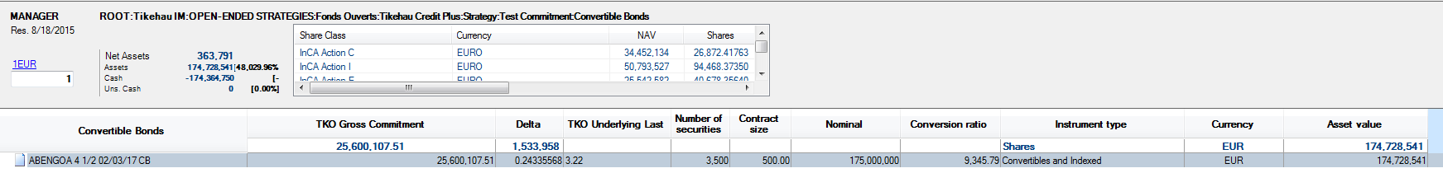

*Convertible Bonds*

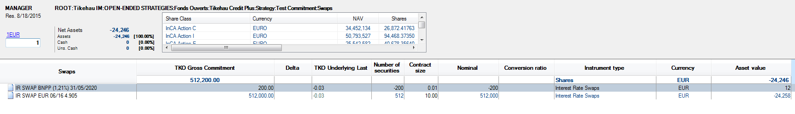

*Swaps*

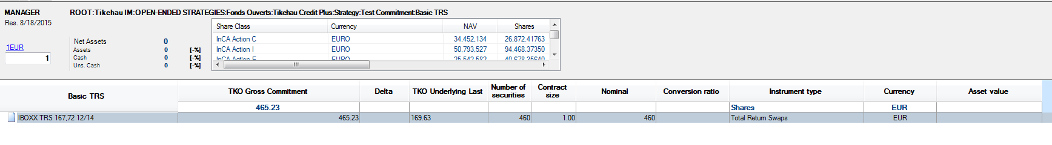

*Basic TRS*

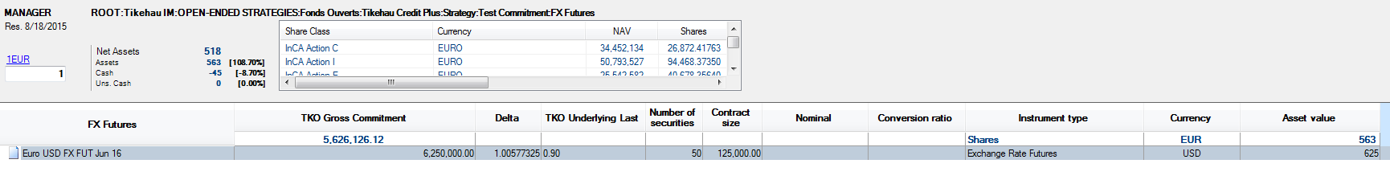

*FX Futures*

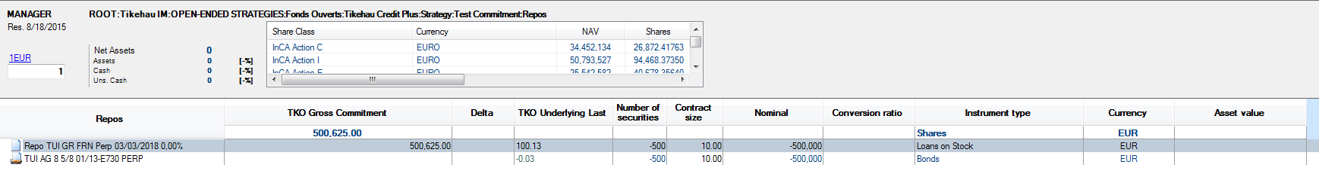

*Repos*

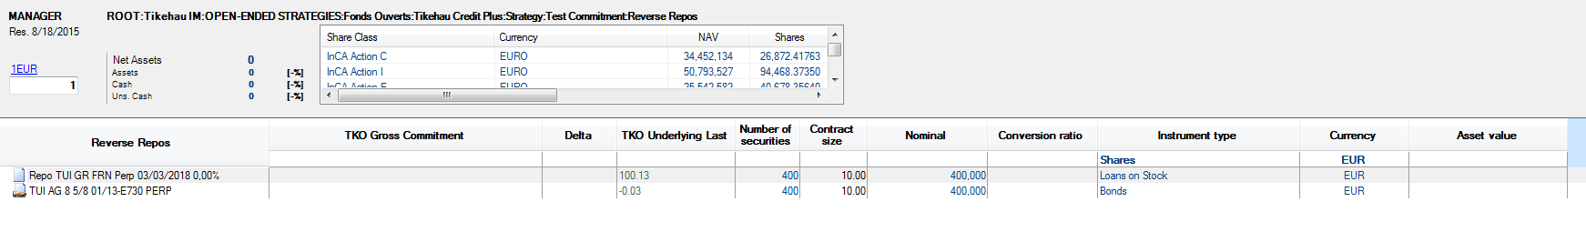

*Reverse Repos*